Goal 1:  Structure of an atom  Pick 2-3 →  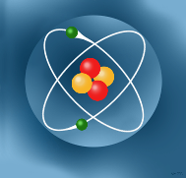 | Read “Inside the Atom” CK12 Flexbook. Update your note guide by answering the learning targets.
 | Choice A – Videos  Video #1  Video #2  Video #3 | Choice B - Tutorial  ChemThink Atomic Structure Tutorial | Choice C - Additional Readings  Website #1 and Website #2 | Choice D – SlideShare  View the SlideShare presentation on atoms
 | As a whole class, we will build models of different atoms, using Carolina Biological’s Atomic Elements app. This app can be found in iTunes and is free for download, if you wish to continue playing with the app on your own.
 | Science Talks – With your shoulder partner, discuss the parts of an atom and the significance of the atomic number and atomic mass.
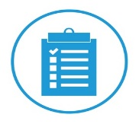 | Check Up – Your goal for content mastery is 80% or better on the assessment | Choice A – Move to Goal #2 if you showed content mastery | Choice B – Use the Parts of an Atom Quizlet Flashcards and your note guide to remediate and build fluency | Choice C – Find a peer or your teacher for small group remediation and review in preparation for credit recovery
Goal 2:  Periodic Table of Elements  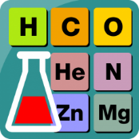 | Step 1 - Rally Read “Modern Periodic Table of Elements” CK12 Flexbook. Update your note guide by answering the learning targets.
 | Step 2A – Explore Chem4Kids |  | Step 2B – Read the Periodic Table Summary found on the learning module
Step 3 - Find a shoulder partner and have the following discussions:
1) How best to define an element
2) Compare/contrast an atom and element
3) Explain how the Periodic Table of Elements is organized and the meaning of Periods and Groups
Artifact | Create an artifact which is modeled after the Periodic Table of Elements, using whatever items/information you wish. Remember our discussions in class about why elements are grouped the way that they are! View some examples that I found online on the learning module.
 | Check Up – Your goal for content mastery is 80% or better on the assessment | Choice A – Move to the Quiz if you showed content mastery | Choice B – Visit the How Stuff Works site on the PTE to help remediate and build fluency. (Multiple pages) | Choice C – Find a peer or your teacher for small group remediation and review in preparation for credit recovery

Quiz Preparations

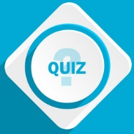 | Step 1 - Spend 15 minutes working on filling in the appropriate answers to the study guide. DO NOT use your note guide or any other resource! | Step 2 – Spend another 10 minutes in Science Talks with your peers and note guide. Use the answer key which is found on the learning module, to check your answers, fill in missing responses or make necessary changes. | Step 3 – Play Quizizz in class and try to score 80% or better. Your teacher will provide you with the class code. | Step 4 - Take your quiz and post your answers to Edmodo. Your teacher will provide you with directions for credit recovery if you score below an 80%.

