1. As heat is added, what happens to the atoms in a solid?  - They begin to contract.  - They begin to expand.  - They begin to vibrate rapidly.  - They begin to slow down.  2. Suppose you pour a glass of ice water and set it on the kitchen table. After a few minutes, the outside of the glass will be covered with drops of water. Why did this happen?  - Oxygen in the air cooled and condensed onto the cold glass.  - Water vapor in the air cooled and condensed onto the cold glass.  - Water vapor in the air cooled and evaporated onto the cold glass.  - Water seeped through pores in the glass.  3. A substance is able to flow freely within a container. What state of matter is the substance in?  - Liquid  - Gas  - Solid  - Plasma  4. What are the characteristics of a solid?  - Solids have an indefinite shape and definite volume.  - Solids have a definite shape and no definite volume.  - Solids have an indefinite shape and no definite volume.  - Solids have a definite shape and definite volume.  9. How are solids and liquids similar?  Solids and liquids both have particles that touch.  Solids and liquids both take the shape of their container.  Solids and liquids both have no definite shape.  Solids and liquids both can not move freely.  10. Alex noticed that a metal door that sticks on hot days does not stick when it cools off at night. This is because the metal contracts as it cools. The reason for this is that, as the metal cools, the atoms  - become smaller and take up less space  - slow down and move closer together  - merge together to form fewer atoms  - speed up and move farther apart  Cumulative Review:  11. What do the small particles protons, neutrons, and electrons compose?  - Cells  - Atoms  - Space  - Electricity  12. What are all atoms with the same number of protons called?  - Cells  - Elements  - Molecules  - Compounds | 5. Why do atoms in a solid still vibrate?  - All solids have some thermal energy.  - Some solids have some thermal energy, and some do not.  - Atoms in a solid do not vibrate.  - None of the above.  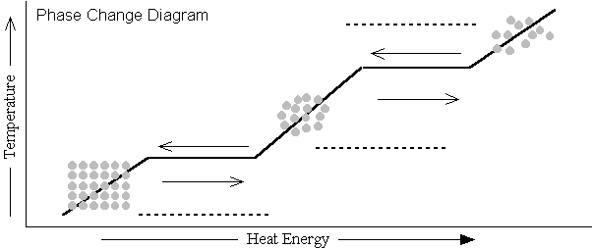  Use the diagram to answer questions 6- 8.  6. When heat energy and temperature are at their lowest, what state of matter is a substance in?  - Gas  - Vapor  - Solid  - Liquid  7. When heat is added to a liquid, what occurs?  - Liquid molecules begin to condense to form a solid.  - Liquid molecules being slow down to become a gas.  - Liquid molecules begin to spread out indefinitely to become a gas.  - Liquid molecules begin to slow down to become a solid.  8. According to the phase change diagram, what happens as temperature and heat energy increase?  - Matter condenses  - Substances expand when heated  - Atoms become less active  - Phase change slows down

