6.P.2.3 –Physical Properties of Matter Study Guide
Topics include – solubility, density, melting point, boiling point, freezing point

Part 1: Solubility - know the following vocabulary
Concentrated Solution Dilute Solution Heterogeneous Solution
Homogeneous Solution Insoluble Saturated Solution
Solubility Soluble Solution
Solute Solvent Supersaturated Solution
Universal Solvent Unsaturated Solution
____________________- do not appear “the same” throughout. “Least mixed”. Particles are large enough to be seen.
____________________- appear the same throughout, “well mixed”, particles are very small – cannot be seen
___________ - a type of homogeneous mixture formed when one substance dissolves in another. “Best mixed” of all mixtures (EX: Kool-aid powder mixed with water)
___________ - the substance that is dissolved in a solution (EX: Kool-aid mix)
___________ - the substance that does the dissolving in a solution (EX: water)
__________________– Water is one because it can dissolve many substances
______________ - the amount of a solute that can be dissolved in a give amount of solvent
_____________ - term that describes a substance that dissolves in another substance
_____________ - a substance that does not dissolve (or very little dissolves) in another substance (EX: spoon)
_____________________ - a solution in which a little amount of solute is dissolved in a large amount of solvent (watered down)
_____________________ - a solution in which a lot of solute is dissolved in a small amount of solvent (EX: frozen orange juice)
_____________________ – a solution that contains all the solute that can normally be dissolved at a given temperature
__________________________ – a solution what contains more solute (dissolved material) than normal
__________________________ – a solution that is capable of dissolving more solute (not saturated)

3 Ways to Speed Up the Rate of Solubility
1) Increase the rate of ________________
2) Increase the _________________ of the solute
3) Raise the _________________ of solvent
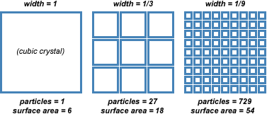

Part 2: Density - know how to solve a problem using the density triangle
Click on the link for practice problems on density….
http://www.algebralab.org/practice/practice.aspx?file=word_density.xml
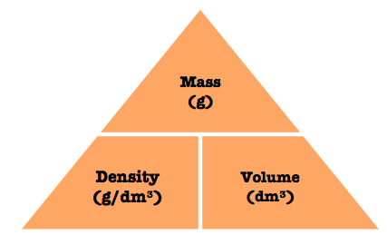
Part 3: Melting Point, Freezing Point, Boiling Point
1) Know the melting/freezing and boiling point of water in degrees Celsius
2) Revisit the phase change graph shown below
