6.P.2.3 –Physical Properties of Matter Study Guide
Topics include – solubility, density, melting point, boiling point, freezing point

Part 1: Solubility - know the following vocabulary
Heterogeneous mixture - do not appear “the same” throughout. “Least mixed”. Particles are large enough to be seen.
Homogeneous Mixture - appear the same throughout, “well mixed”, particles are very small – cannot be seen
Solution - a type of homogeneous mixture formed when one substance dissolves in another. “Best mixed” of all mixtures (EX: Kool-aid powder mixed with water)
Solute - the substance that is dissolved in a solution (EX: Kool-aid mix)
Solvent - the substance that does the dissolving in a solution (EX: water)
Universal solvent – Water is one because it can dissolve many substances
Solubility - the amount of a solute that can be dissolved in a give amount of solvent
Soluble - term that describes a substance that dissolves in another substance
Insoluble - a substance that does not dissolve (or very little dissolves) in another substance (EX: spoon)
Dilute solution - a solution in which a little amount of solute is dissolved in a large amount of solvent (watered down)
Concentrated solution - a solution in which a lot of solute is dissolved in a small amount of solvent (EX: frozen orange juice)
Saturated solution – a solution that contains all the solute that can normally be dissolved at a given temperature
Supersaturated solution – a solution what contains more solute (dissolved material) than normal
Unsaturated solution – a solution that is capable of dissolving more solute (not saturated)

3 Ways to Speed Up the Rate of Solubility
1) Rate of stirring
2) Surface area of solute
3) Temperature of solvent
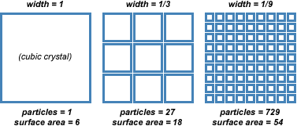

Part 2: Density - know how to solve a problem using the density triangle
Click on the link for practice problems on density….
http://www.algebralab.org/practice/practice.aspx?file=word_density.xml
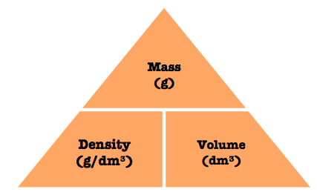
Part 3: Melting Point, Freezing Point, Boiling Point
1) Know the melting/freezing and boiling point of water in degrees Celsius
2) Revisit the phase change graph shown below
