6.P.2.1 Recognize that all matter is made up of atoms and atoms of the same element are all alike, but are different from the atoms of other elements.
a. I will investigate the structure of an atom (i.e. protons, neutrons, electrons).
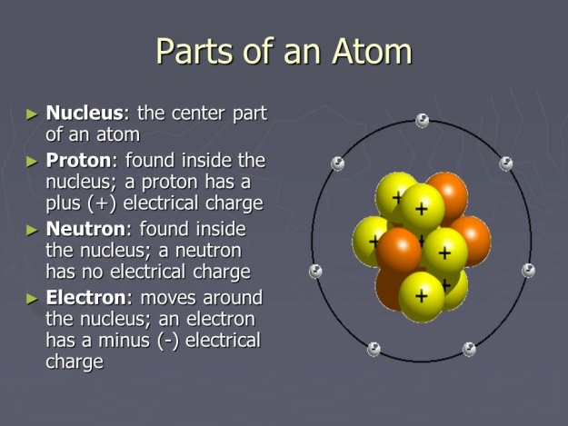
b. I will define an element.
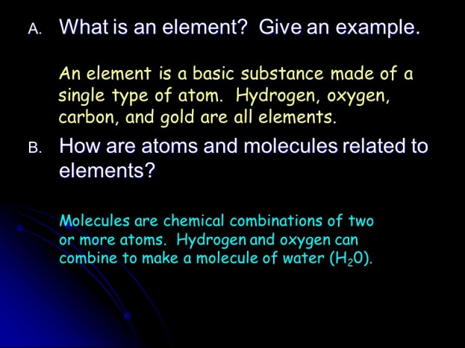
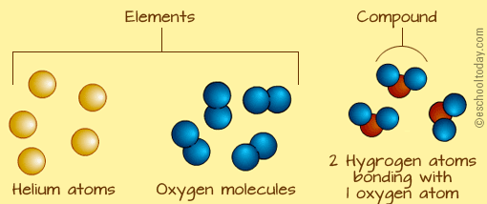
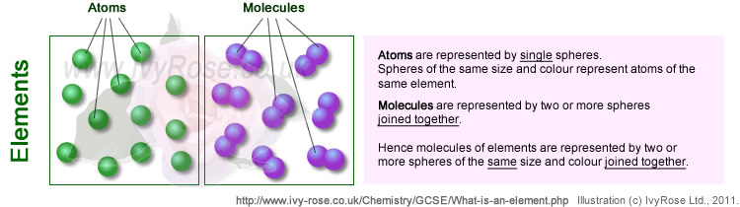
Student Notes:

c. I will compare and contrast an atom and element.
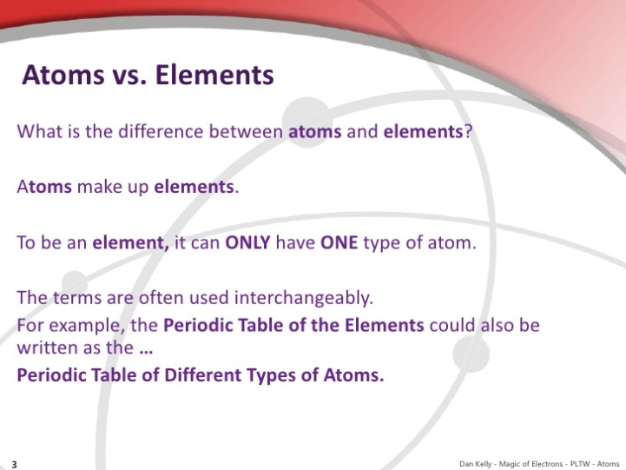
d. I will group elements based on physical properties such as melting point, boiling point, and freezing point.
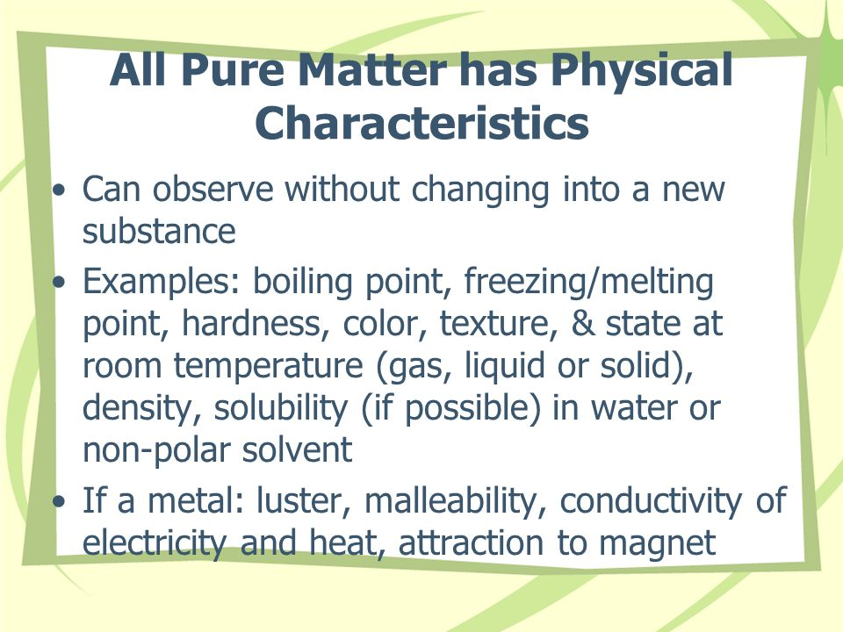

Student Notes:

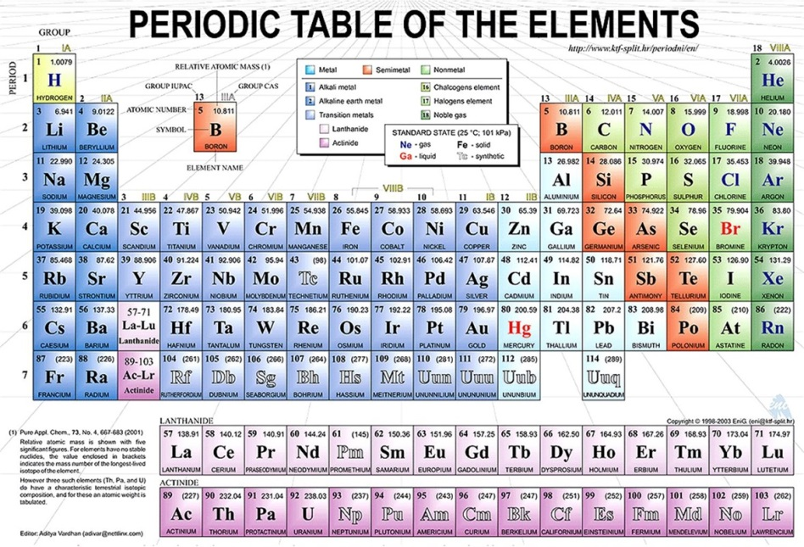
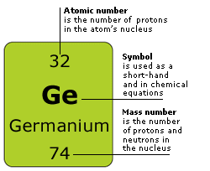

Summary:
There are more than 100 elements that combine in a multitude of ways that make up all of the living and nonliving things that we encounter. Recognize that matter is composed of extremely small particles, too small to be seen with a classroom microscope, called atoms. Atoms have all of the properties of matter in that all atoms have mass and occupy space. Atoms are the smallest part of an element that has the chemical properties of the element. Recognize that all atoms of the same element have the same properties; i.e. all iron atoms have the same mass and occupy the same amount of space; therefore, all matter made of iron has the same properties because of the iron atoms. Also, iron atoms are different from carbon atoms or from any other element.
Student Notes:

6.P.2.2 Explain the effect of heat on the motion of atoms through a description of what happens to particles during a change in phase.
a. I will identify that atoms are in constant movement.
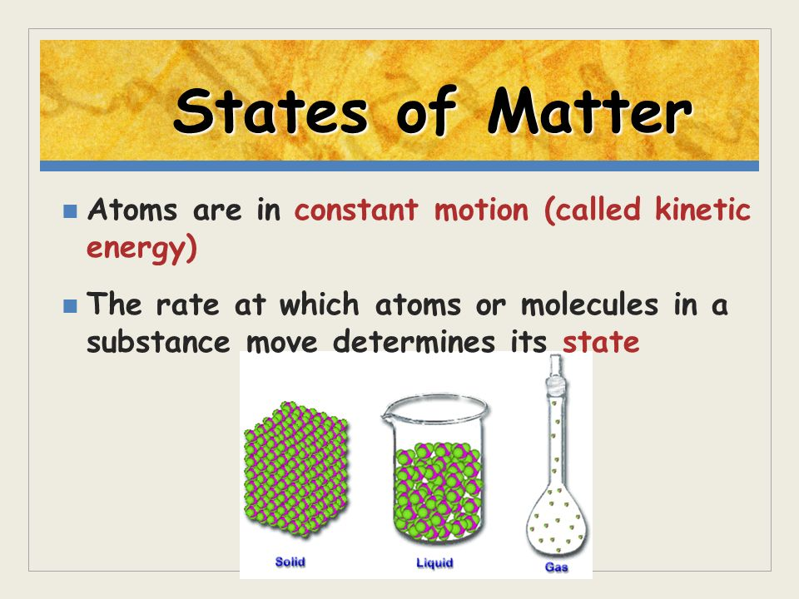
b. I will analyze particle movement in relation to temperature in solids, liquids, and gases.
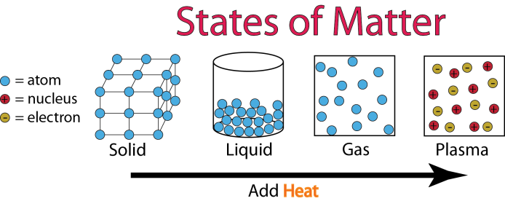
c. I will compare the characteristics of a solid, liquid, and gas.
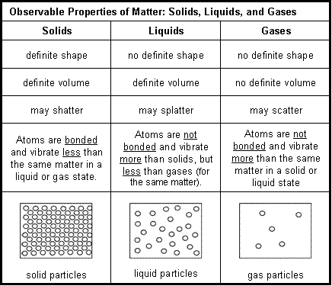
Student Notes:

d. I will explain that phase changes occur due to temperature change.
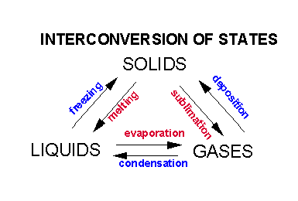
e. I will compare and contrast the properties of solids, liquids, and gases when contained.
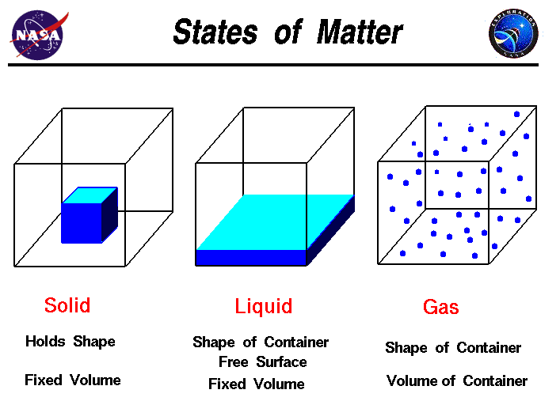
Summary:
A substance in a: Solid phase is relatively rigid, has a definite volume and shape. The atoms that comprise a solid are packed close together and are not compressible. Because all solids have some thermal energy, its atoms do vibrate. However, this movement is very small and very rapid, and cannot be observed under ordinary conditions. When heat is added a solid can become a liquid. Liquids have a definite volume, but are able to change their shape by flowing. Liquids are similar to solids in that the particles touch however, the particles are able to move around. Since particles are able to touch, the densities of liquid will be close to that of a solid (water is a special exception). Since the liquid molecules can move, they will take the shape of their container. When heat is added, a liquid can become a gas. Gases have no definite volume or shape. If unconstrained, gases will spread out indefinitely. If confined, they will take the shape of their container. This is because gas particles have enough energy to overcome attractive forces. Each of the particles is well separated, resulting in a very low density. Energy appears in different forms. Heat energy is in the disorderly motion of molecules. Atoms and molecules are perpetually in motion. Increased temperature means greater average energy of motion so most substances expand when heated. Most substances can exist as a solid, liquid or gas depending on temperature.
Student Notes:

6.P.2.3 Compare the physical properties of pure substances that are independent of the amount of matter present including density, boiling point, melting point and solubility to properties that are dependent on the amount of matter present to include volume, mass and weight.

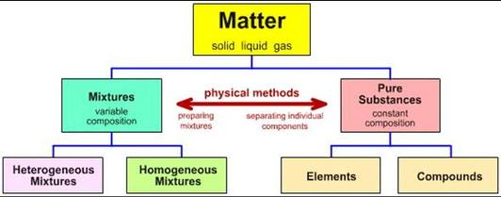

a. I will define solubility
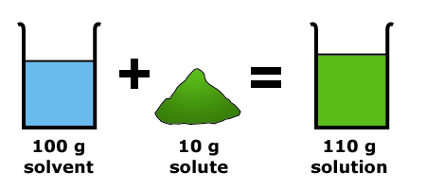

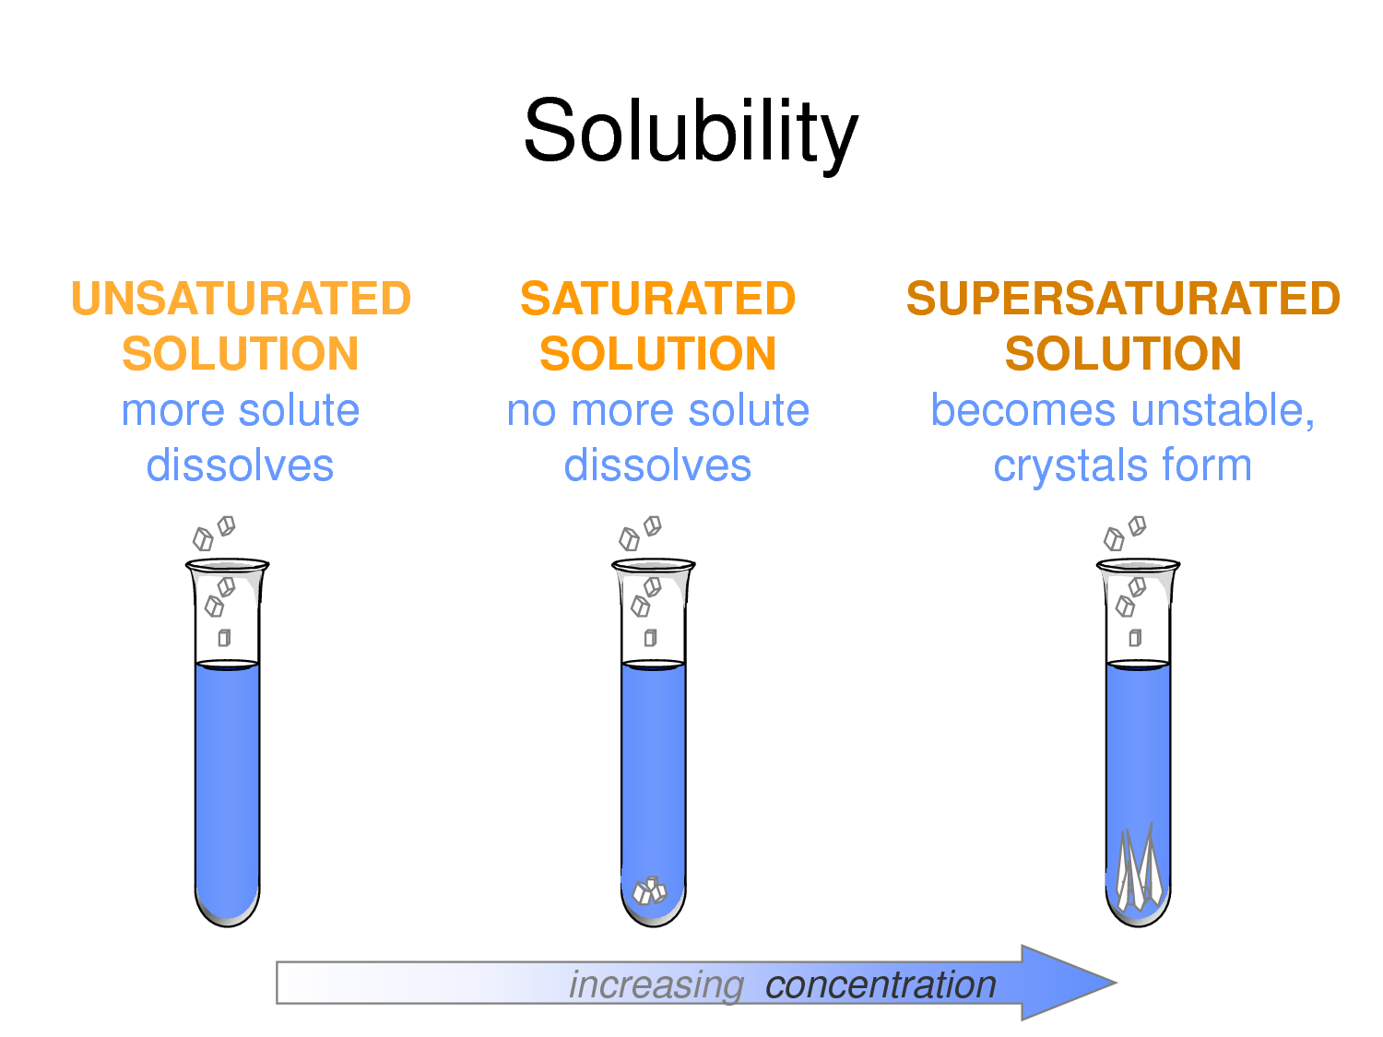
Student Notes:

b. I will define density.
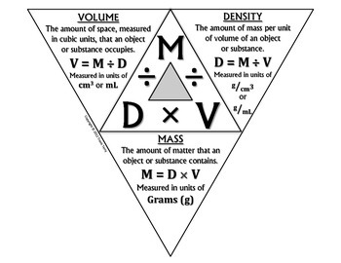
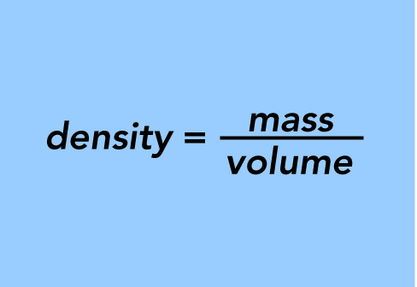
c. I will define boiling, freezing and melting point.
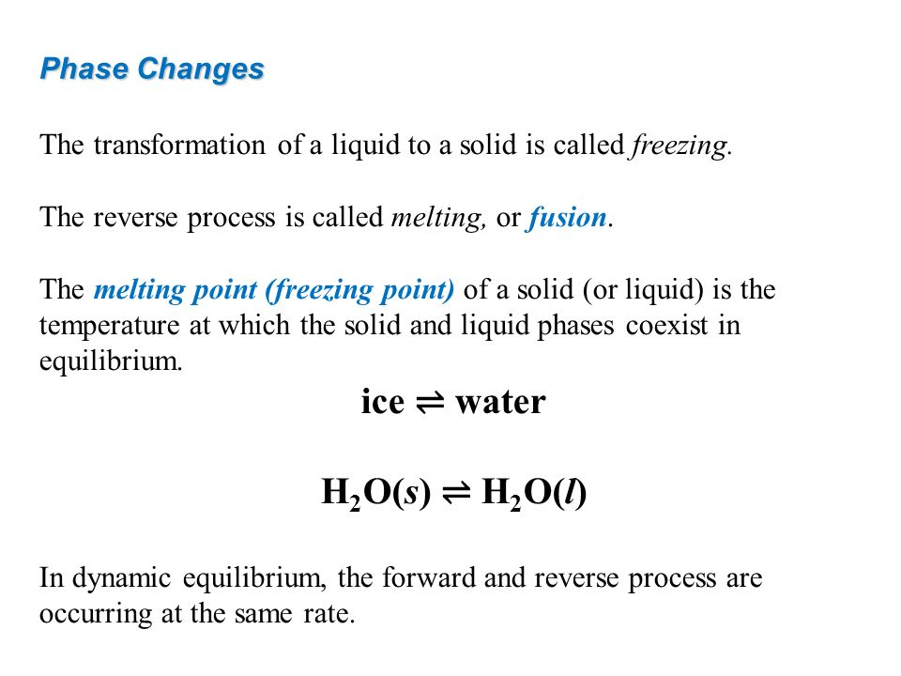
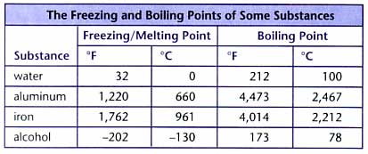

Student Notes:
1) What is the density of a piece of wood that has a mass of 25.0 grams and a volume of 29.4 cm³?
2) The volume of a solution was measured in a graduated cylinder (shown below). If the mass of solution is measured to be 60.75 grams, what is the density of the solution?

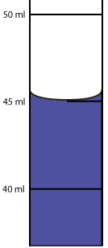

3) A piece of wood that measures 3.0 cm by 6.0 cm by 4.0 cm has a mass of 80.0 grams. What is the density of the wood? Would the piece of wood float in water? (volume = L x W x H)

d. I will investigate the properties of density, boiling point, melting point, and solubility
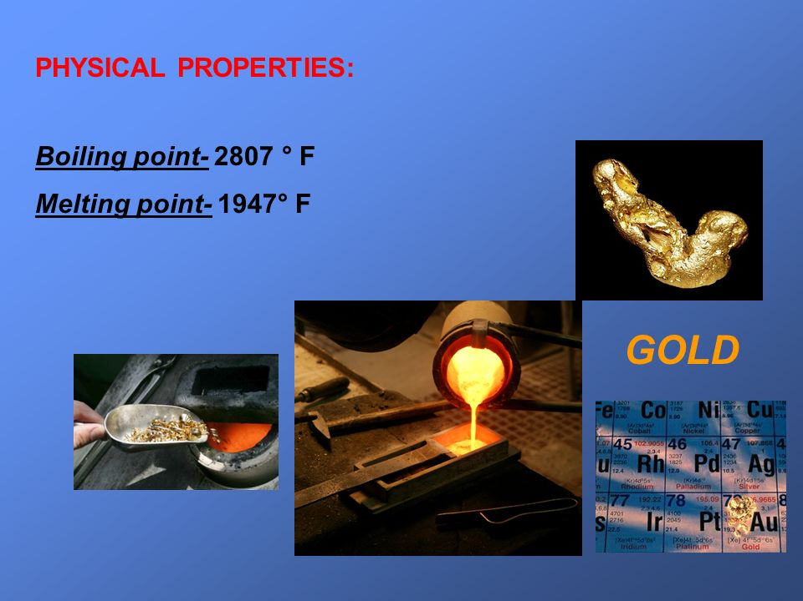
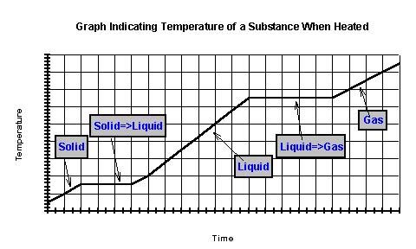
Summary:
A substance has characteristic properties such as density, a boiling point, melting point and solubility, all of which are independent of the amount of the substance and can be used to identify it. Physical properties involve things that can be measured without changing the chemical properties. Matter can undergo physical changes which affect only physical properties. Physical changes can involve changes in energy. Solubility means the amount of solute that can be dissolved in a specific volume of solvent under certain conditions. A solute’s solubility depends on the chemical nature of the solvent. Another important factor that influences solubility is the temperature of the system (the solute and the solvent). The most common solvent is water. Density is a property that describes the relationship between mass and volume. Investigate the physical properties of pure substances in terms of the unique temperatures at which each substance undergoes state changes. Investigate that melting and freezing of a pure substance takes place at the same temperature and the boiling temperature is the same as the maximum condensing temperature. The temperature remains constant during state changes of pure substances.
Student Notes:

